Name : More Mayur Shankar
Project Name: Greenmart
Frontend: React .js
Backend: Node.js Exprees.js
Database: MongoDB
Authentication: JWT
Date of Submission:

Project Description :
GreenMart is a full-stack web application that allows users to order groceries online and have them delivered by assigned delivery staff. The project is built using the MERN Stack (MongoDB, Express.js, React.js, Node.js) with role-based login for Admin, Users.

How it works:
- Users can:
  - Register/Login
  - Browse products
  - Add to cart
  - Place orders
  - Track their order status
- Admin can:
  - Manage products (add/edit/delete)
  - View all orders
  - Assign orders to delivery staff
  - Track monthly reports (orders, revenue, stock)

Key Features:
  - Role-based authentication (User, Admin, )
  - Stock management (auto-reduce after order)
  - Email confirmation for orders
  - Responsive Bootstrap UI
  - Monthly sales and product insights

Project Images:
Home Page:
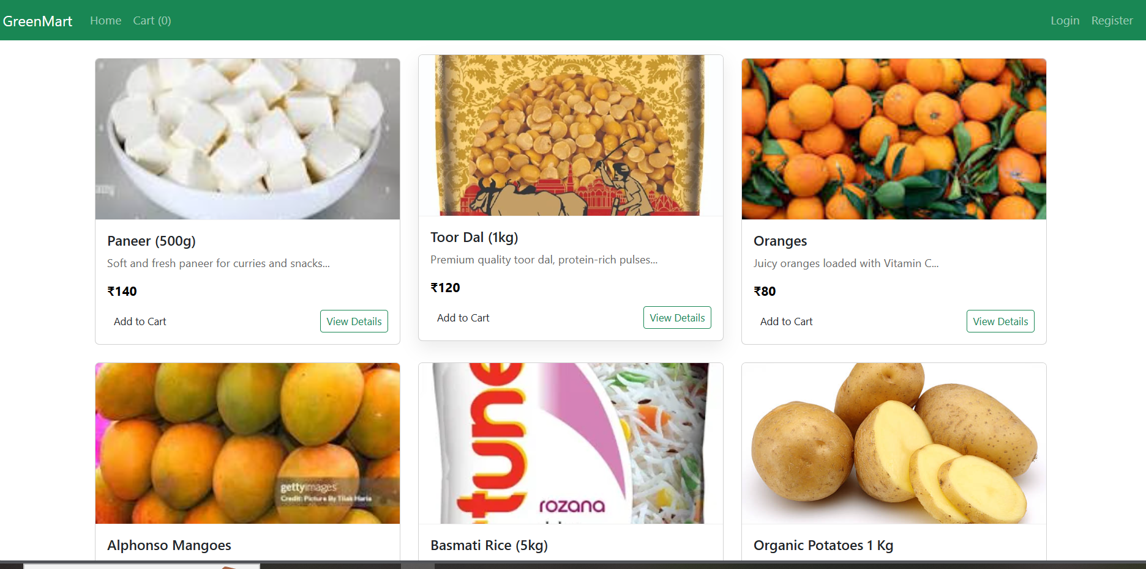

Register Page:

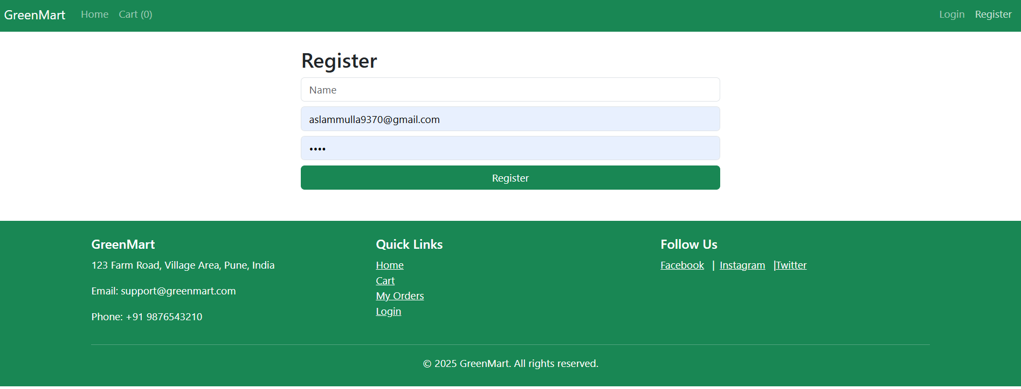

Login page:
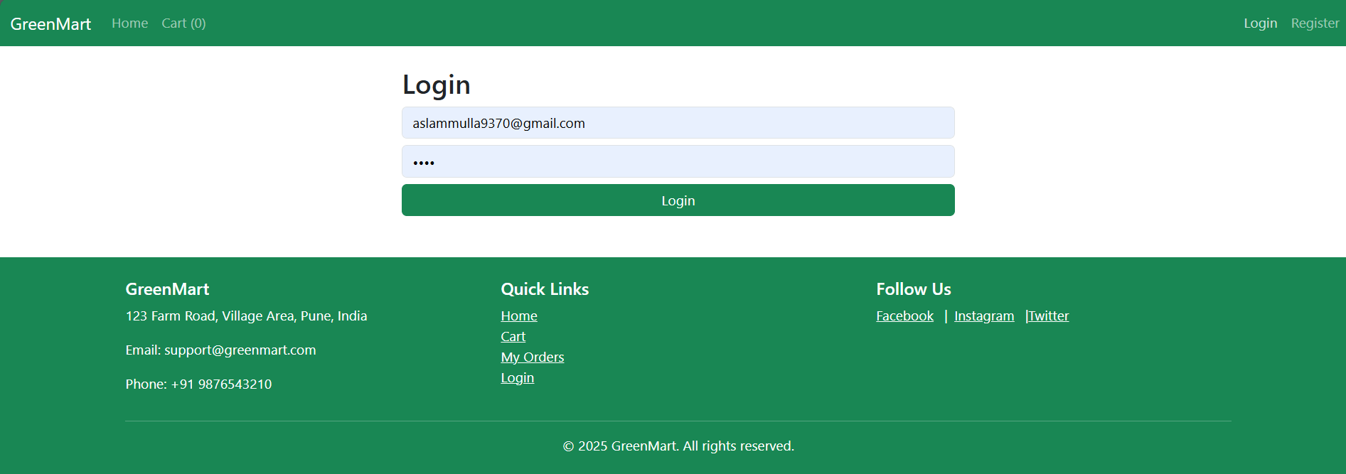

Product Details Page:
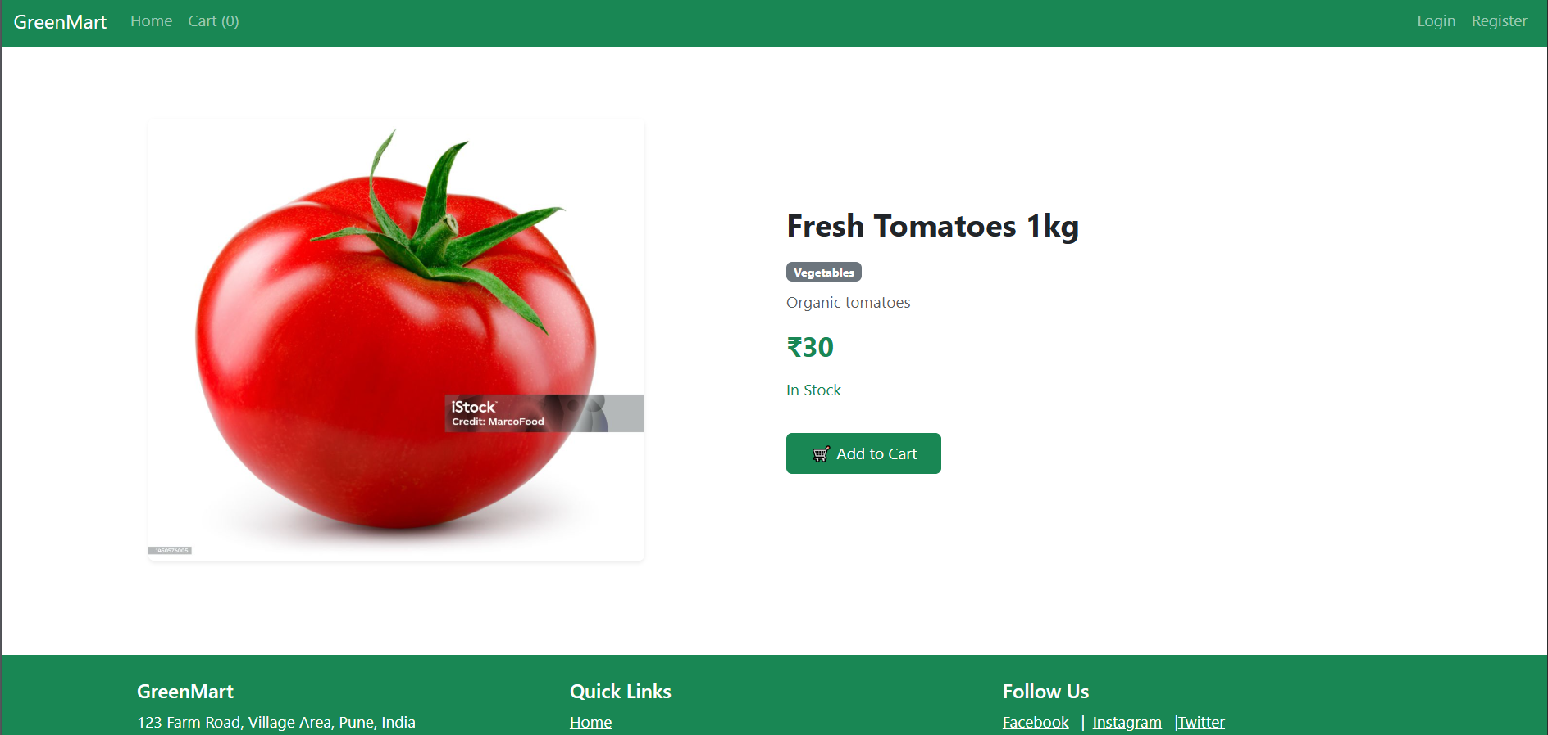

User Dashbord:
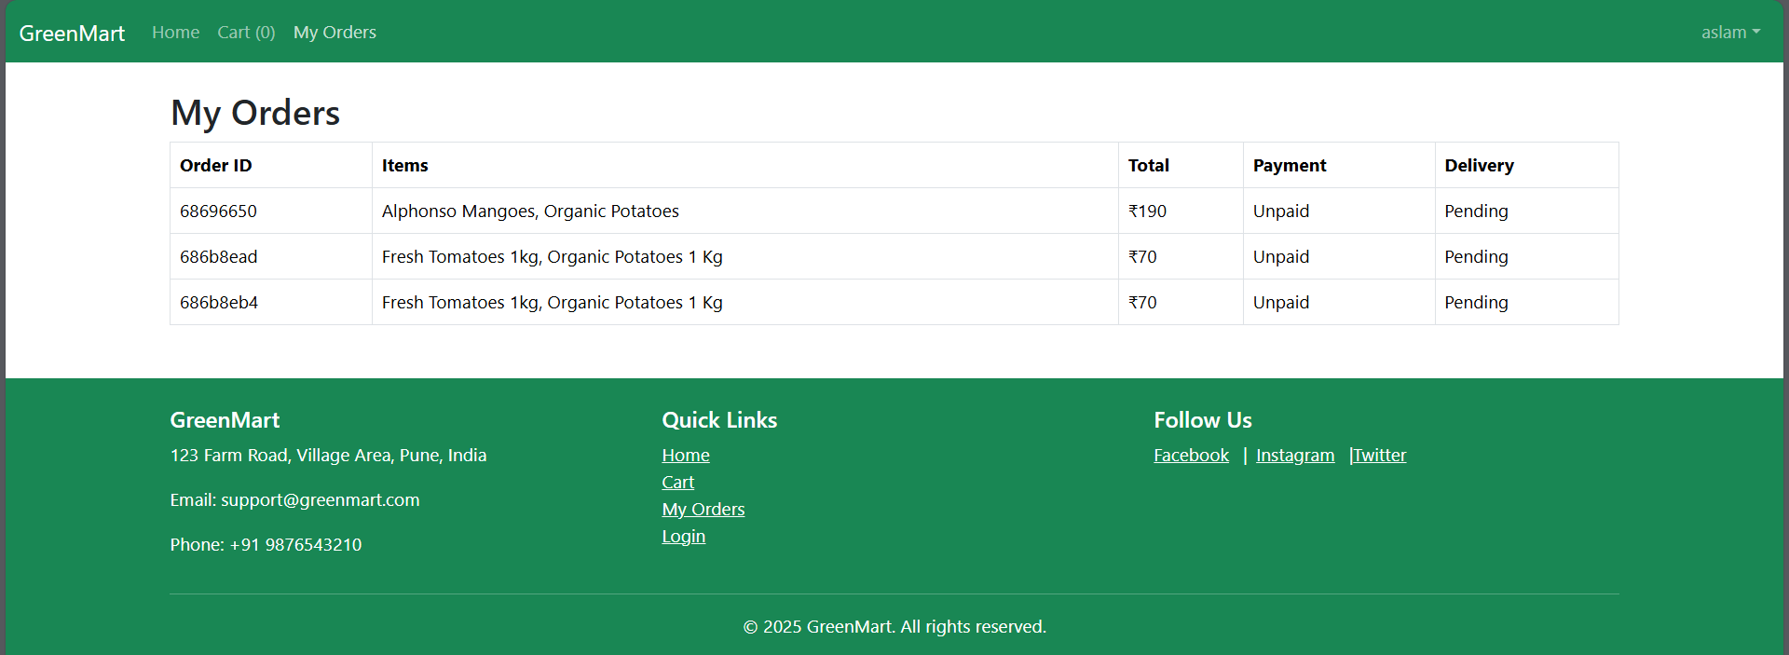
Cart page:
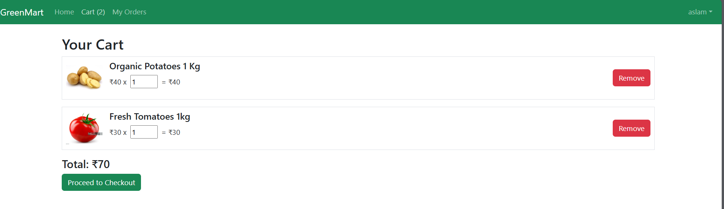
Checkout:
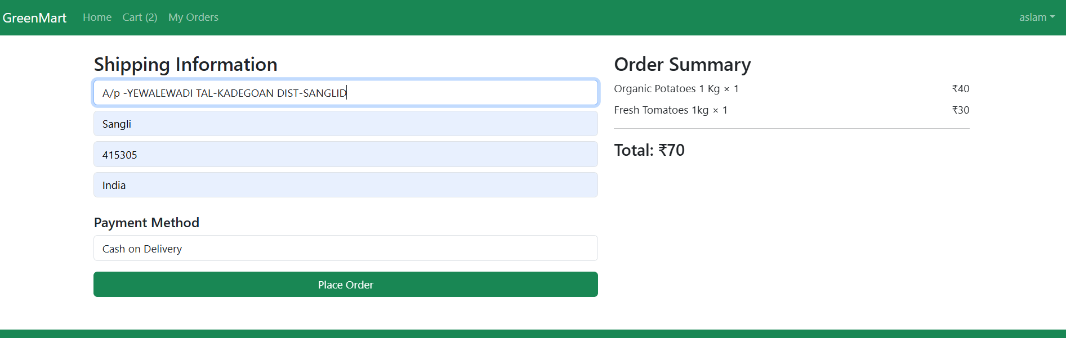

Order Confirmation Mail :
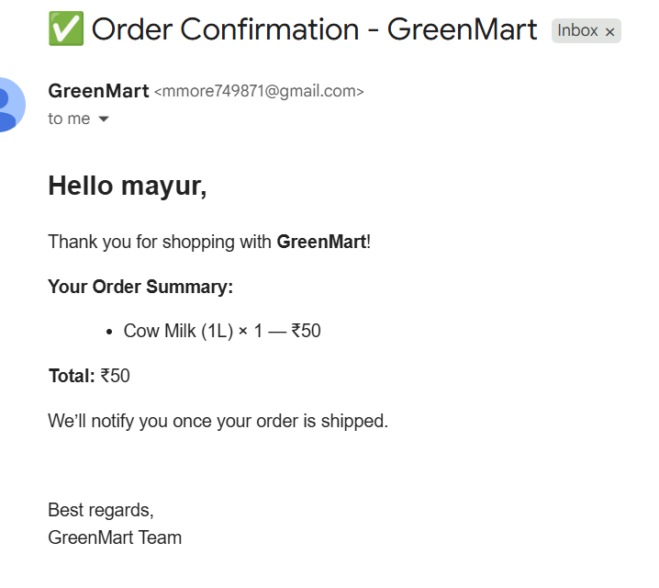
Admin DashBorad:
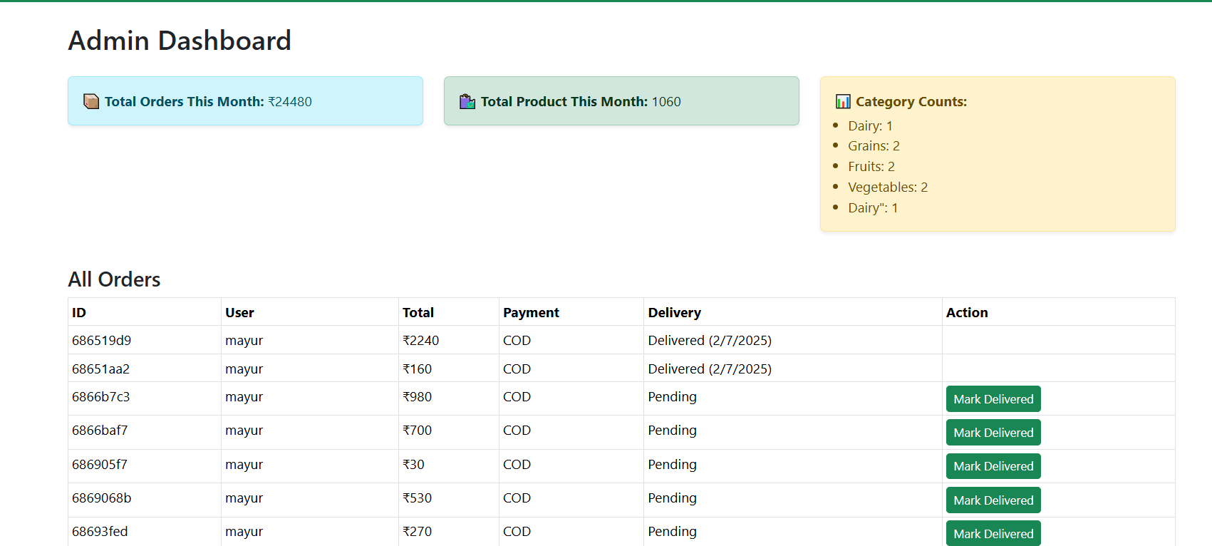

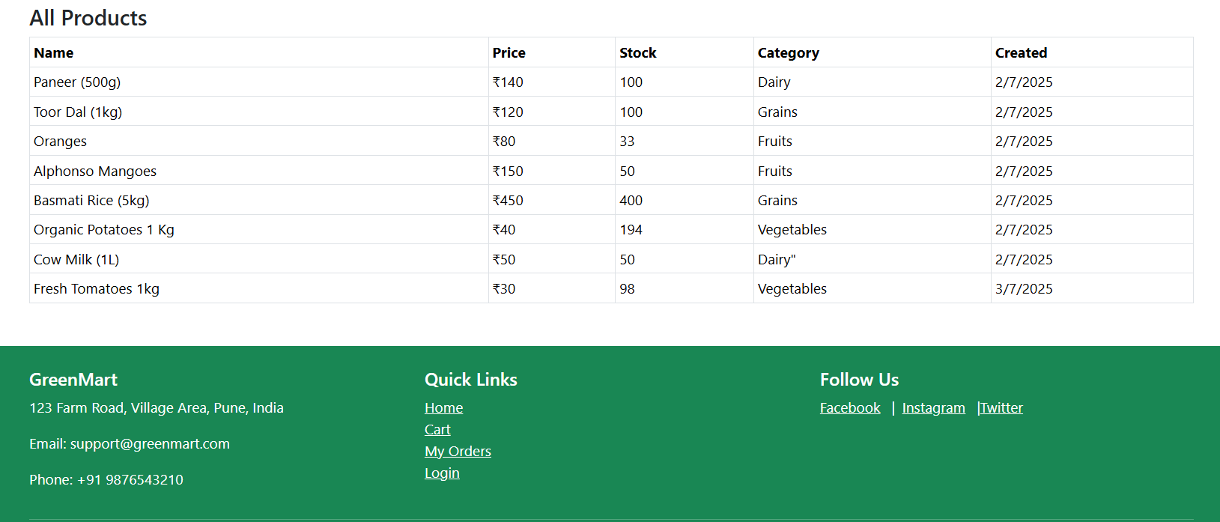

Admin Manage Products:
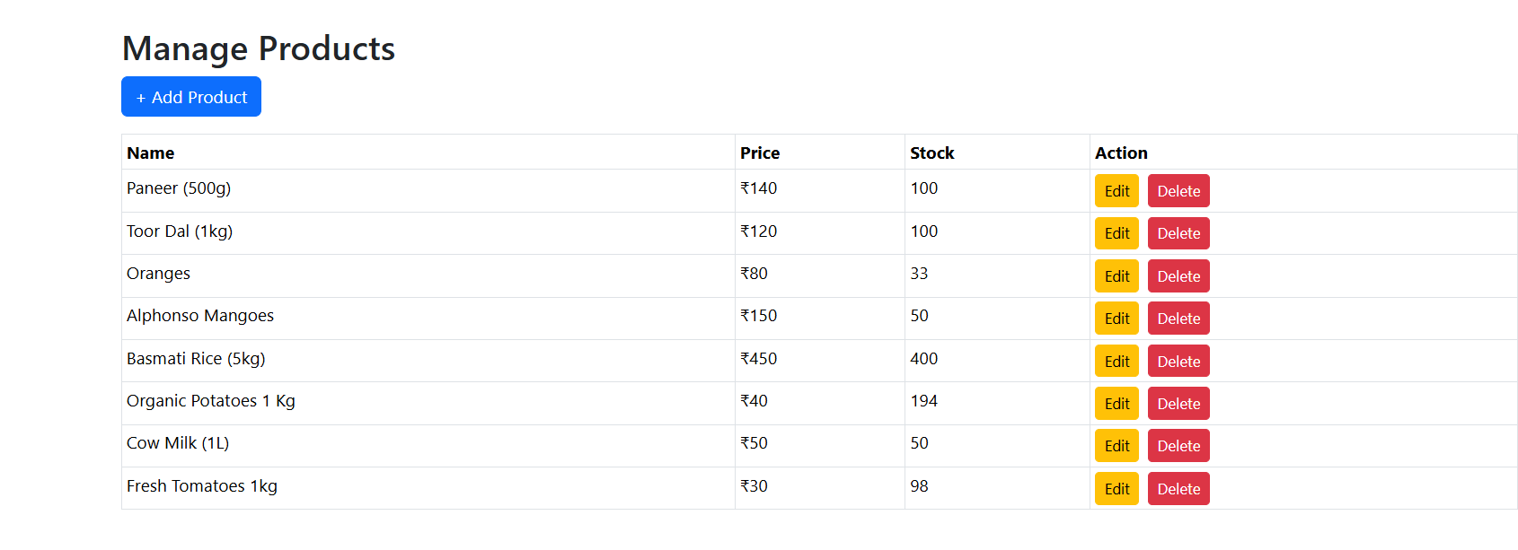
Admin Add Product:
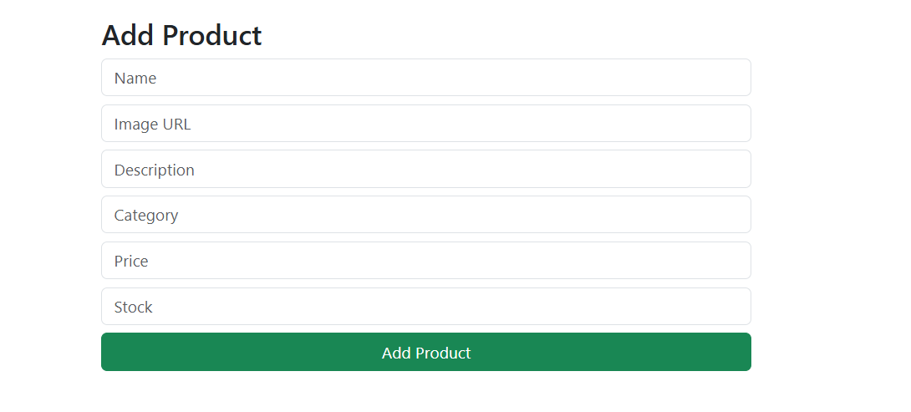
Admin Edit Product:
